**JMeter Performance Testing with CSV Files**

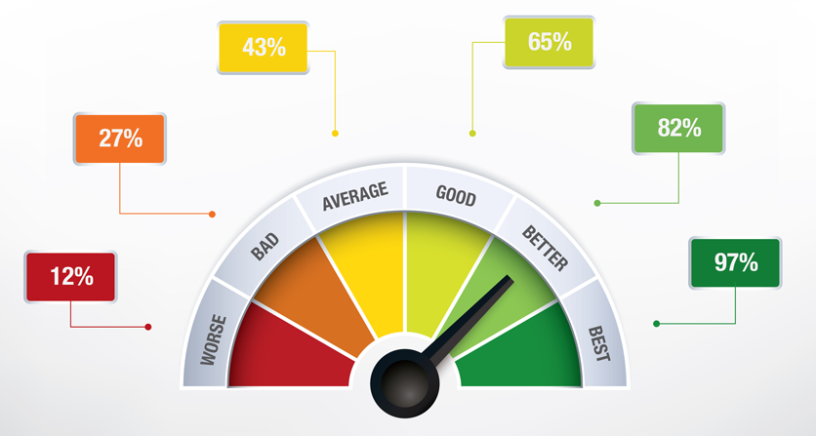**Design and Testing 2**

Ángel Delgado Luna

Belen Garrido López

Alejandro Rodríguez

Ezequiel Portillo Jurado

Mª De Gracia Piñero Pastor

**Index**

1. **Entity chosen and its parameter**
2. **Process followed**
3. **Results**